HATEOAS

1. 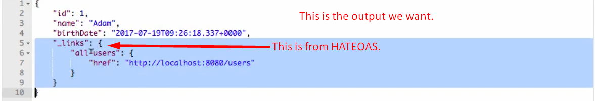
2. 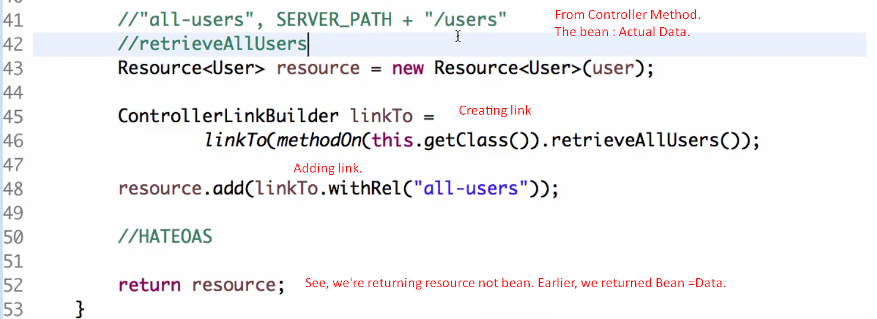

I18n

1. 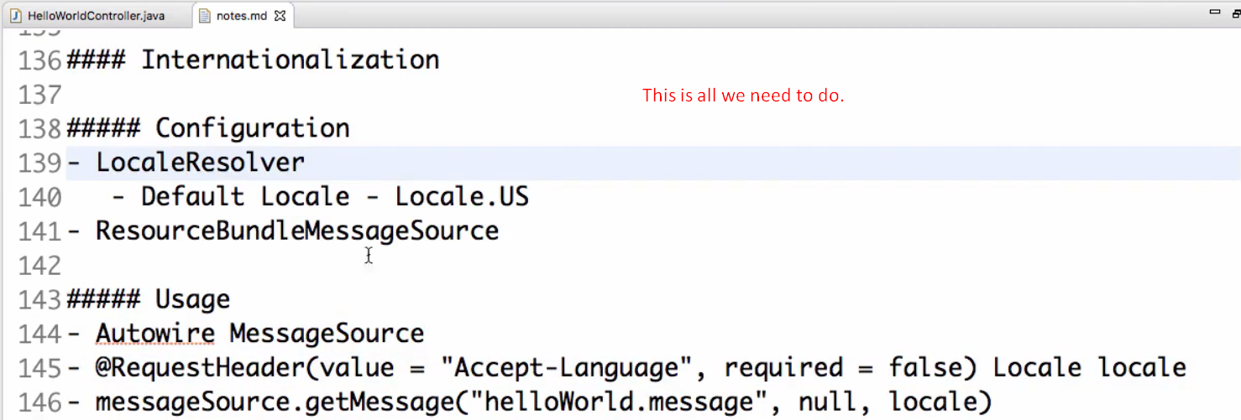
2. 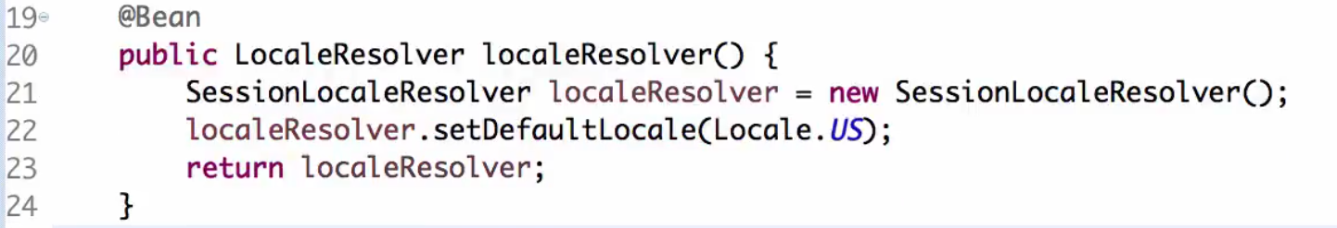
3. 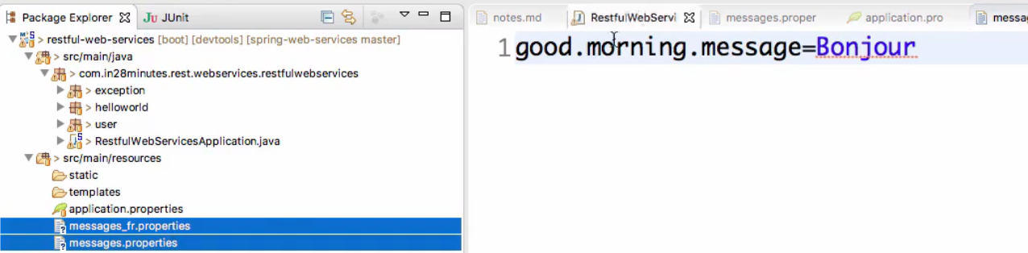
4. 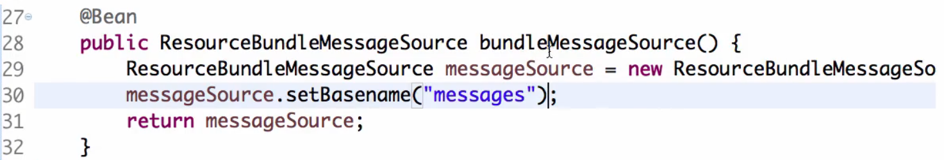
5. 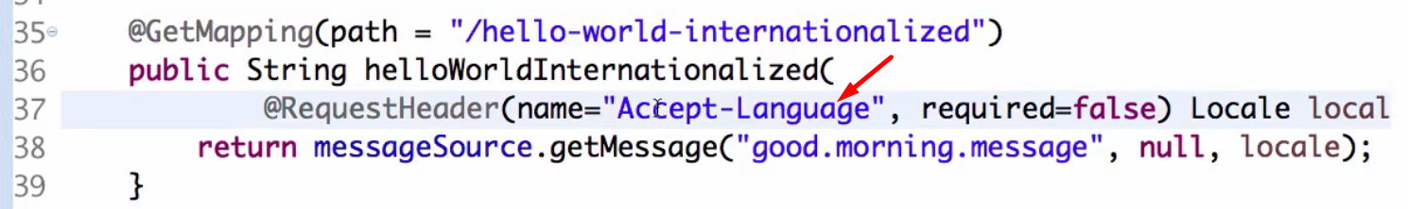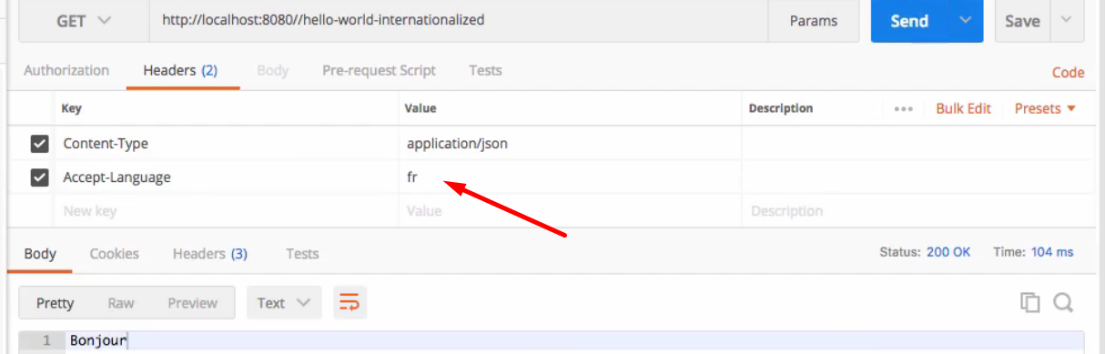

Microservices  
